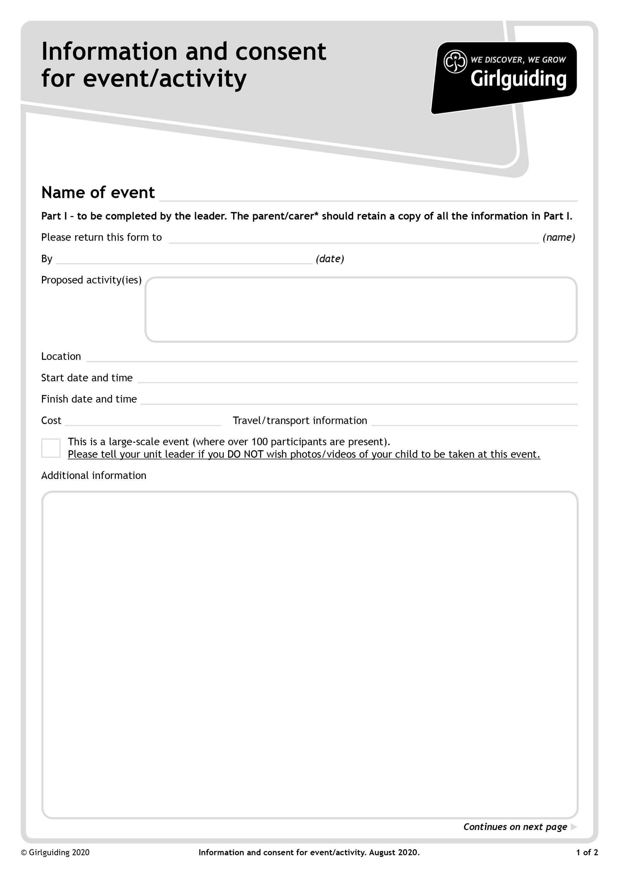

Training and activity sessions

See event flyer.

This form only required for Young Leaders under the age of 18.

Own transport

£5 from unit funds

3pm

From 9.45 am for reception, sessions start at 10.30am

Sweyne Park School, Rayleigh

Bring on 30 April 2022

Essex SE Coming Together Day 2022

Julie Nye –County Adviser for Training

