Essex Award

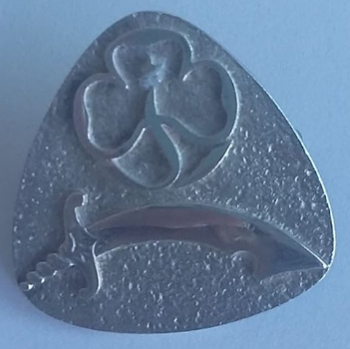

For Leaders who have given contributed considerably to Girlguiding Essex South East at more than one level. For example, someone who has held a County role plus a role at Division, District or unit level.
AWARD NOMINATION FORM
Nominees Full Name:
Membership Number:
Current Guiding Appointment(s):
Reason for Nomination:

Name of Proposer:  BLOCK CAPITALS PLEASE | Name of Seconder:  BLOCK CAPITALS PLEASE
Signature of Proposer:  CAN BE ELECTRONIC | Signature of Seconder:  CAN BE ELECTRONIC
Date:

Please return this form via email to: essexsecc@gmail.com
2022

